Kubernetes Task-1
- Setup Minikube in your local machine.
- Setup k8s master and two worker nodes on ubuntu.
- Run one nginx pod.
- Mugup Master and slave components on k8s.
Task 1 — Setup Minikube on Windows
1. Objective
The objective of this task is to set up a local Kubernetes cluster on a Windows machine using Minikube.
Minikube creates a Kubernetes cluster locally, which allows us to practice:
- Kubernetes Pods
- Deployments
- Services
- Namespaces
- ConfigMaps
- Secrets
- kubectl commands
For this lab, we will use Docker Desktop as the Minikube driver.
2. Architecture
The setup will look like this:
Windows Machine
|
v
Docker Desktop
|
v
Minikube
|
v
Kubernetes Cluster
|
+---------------------------------------+
| |
Control Plane Worker Components Components
| |
+-------------------+-------------------+
|
NGINX Pod
Minikube normally gives you a single-node Kubernetes cluster, where the same node can perform control-plane and workload roles.
3. Prerequisites
Before installing Minikube, make sure you have:
- Windows 10/11
- Administrator access
- Docker Desktop
- kubectl
- Minikube
We will verify each one.
4. Step 1 — Check Windows Version
Open PowerShell.
Run: winver
A Windows version window should appear.
You can close it after checking.
5. Step 2 — Install Docker Desktop
Minikube will use Docker as its container driver.
Download and install Docker Desktop from the official Docker website:
Docker Desktop
During installation, keep the default options unless your environment requires something different.
After installation, restart Windows if Docker Desktop requests it.
6. Step 3 — Start Docker Desktop
Open: Start Menu
↓
Docker Desktop
Wait until Docker Desktop shows that Docker is running.
Then open PowerShell and run: docker --version
Expected output will look similar to:
Docker version 29.x.x, build xxxxxxx
The exact version can be different.
7. Step 4 — Test Docker
Run: docker run hello-world
Docker should download the hello-world image and display a successful message.
You should see something similar to: Hello from Docker!
This message shows that your installation appears to be working correctly.
Validation
Run: docker ps
It is okay if the output is empty because the hello-world container exits after displaying its message.
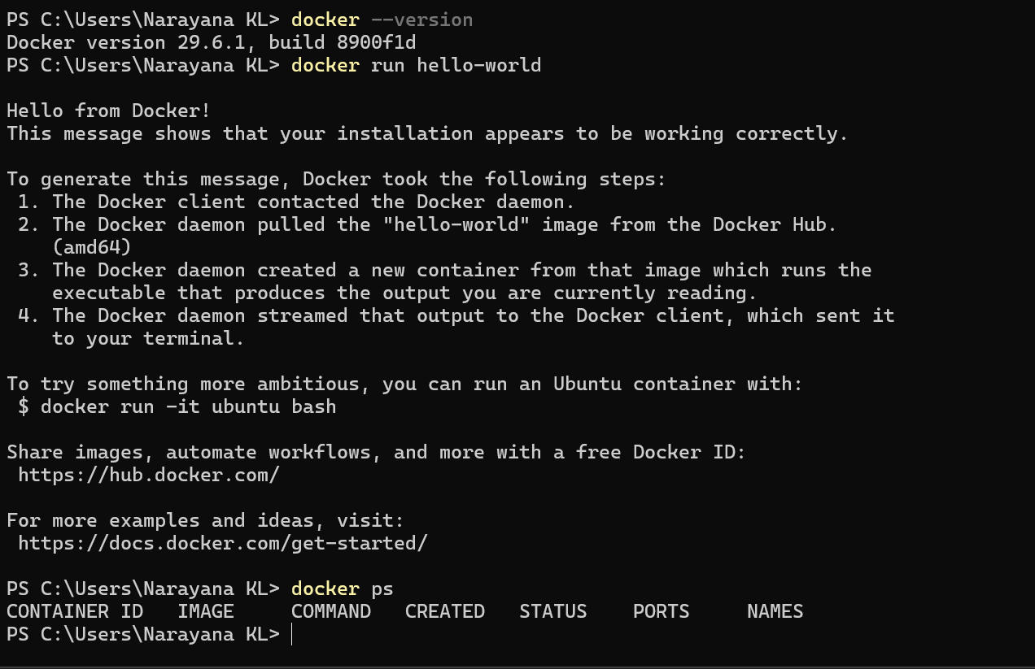
At this point: Docker
|
+---- Working
8. Step 5 — Install kubectl
kubectl is the command-line tool used to communicate with Kubernetes.
You can install it using the official Kubernetes installation instructions:
Kubernetes — Install kubectl on Windows
After installation, open a new PowerShell window.
Run: kubectl version --client
Expected: Client Version: ...
The exact version can be different.
9. Step 6 — Verify kubectl
Run: where.exe kubectl
You should get a path similar to: C:\Program Files\Kubernetes\kubectl.exe
or another location where you installed it.
Then: kubectl version --client
If you get the client version, kubectl is installed correctly. 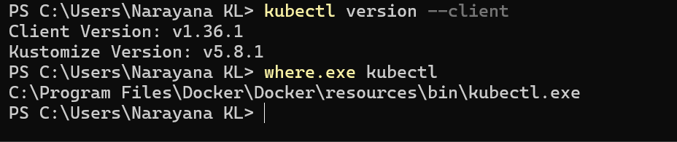
10. Step 7 — Download Minikube
Now install Minikube for Windows.
Use the official Minikube installation documentation:
Minikube — Get Started
1.Download and run the installer for the latest release.
Or if using PowerShell, use this command:
New-Item -Path 'c:\' -Name 'minikube' -ItemType Directory -Force
$ProgressPreference = 'SilentlyContinue'; Invoke-WebRequest -OutFile 'c:\minikube\minikube.exe' -Uri 'https://github.com/kubernetes/minikube/releases/latest/download/minikube-windows-amd64.exe' -UseBasicParsing
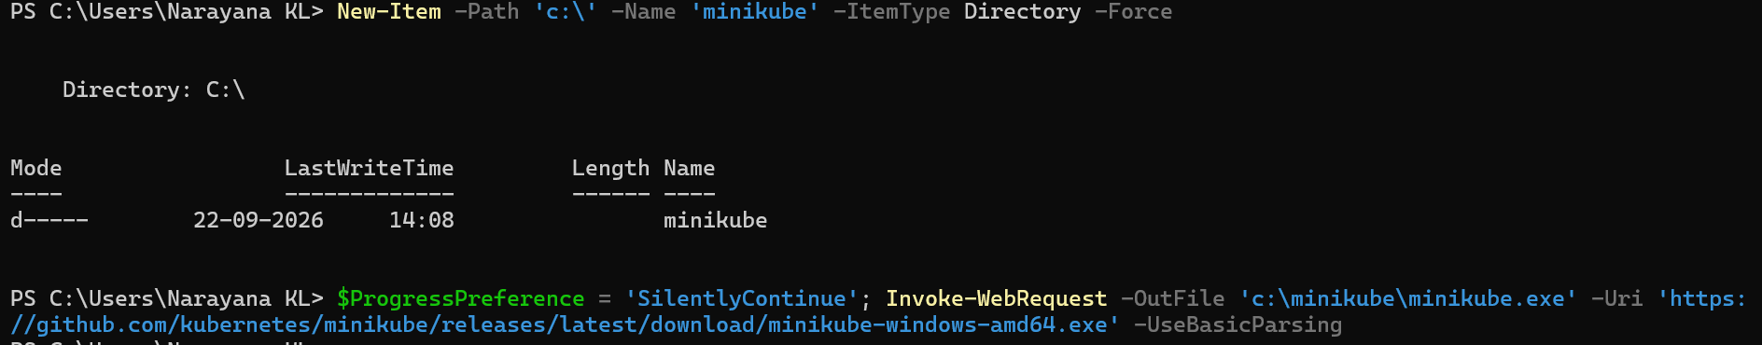
2. Add the minikube.exe binary to your PATH.
Make sure to run PowerShell as Administrator.
$oldPath = [Environment]::GetEnvironmentVariable('Path', [EnvironmentVariableTarget]::Machine)
if ($oldPath.Split(';') -inotcontains 'C:\minikube'){
[Environment]::SetEnvironmentVariable('Path', $('{0};C:\minikube' -f $oldPath), [EnvironmentVariableTarget]::Machine)
}
Open PowerShell as Administrator
- Close this PowerShell window.
- Open Start Menu.
- Search for PowerShell.
- Right-click Windows PowerShell.
- Select Run as administrator.
- Run:
For Windows, install the current Windows executable/package provided there.
After installation, close PowerShell and open a new PowerShell window.
This is important because Windows may need to reload the updated PATH.
11. Step 8 — Verify Minikube
Now run the command that previously failed: minikube version
The exact version will depend on the current Minikube release.
12. If minikube Is Still Not Recognized
If you installed Minikube but still receive:
minikube : The term 'minikube' is not recognized
check whether Windows can find it:where.exe minikube
If it returns a path
For example:
C:\Program Files\Kubernetes\Minikube\minikube.exe
then Minikube exists, but your current PATH may not have been refreshed.
Close all PowerShell windows, open a new one, and run:
minikube version
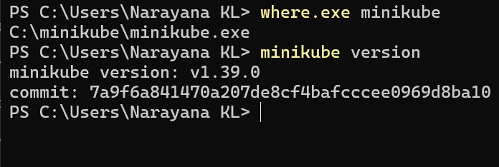
13. Step 9 — Check Minikube Status
Once this works: minikube version
run: minikube status
14. Step 10 — Start Minikube
Make sure Docker Desktop is running.
Then run: minikube start --driver=docker
Minikube will:
- Download required Kubernetes components.
- Create the Minikube node.
- Configure Kubernetes.
- Configure kubectl.
- Start the Kubernetes control-plane components.
- Configure the Docker-based container environment.
The first startup can take several minutes.
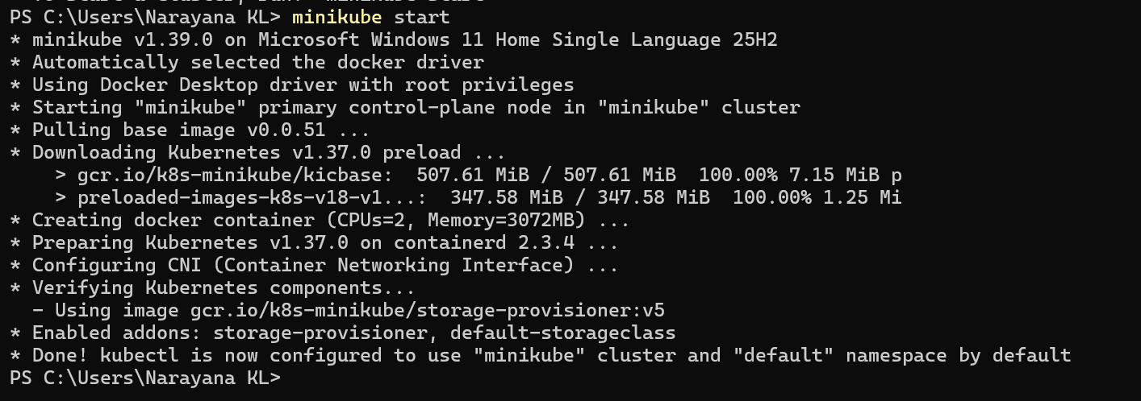
15. Step 11 — Check Minikube Status
Run: minikube status
You should see something similar to: host: Running
kubelet: Running
apiserver: Running
kubeconfig: Configured
This confirms that Minikube is running.
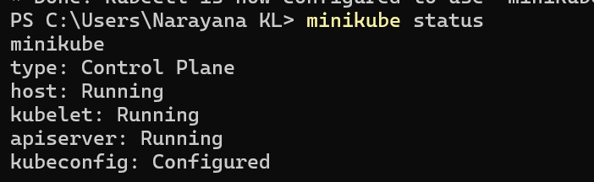
16. Step 12 — Check Kubernetes Nodes
Run: kubectl get nodes
Expected output will look similar to:
NAME STATUS ROLES AGE VERSION
minikube Ready control-plane ... v...
The important part is:
STATUS
Ready
17. Step 13 — Check Cluster Information
Run: kubectl cluster-info
You should get information about the Kubernetes control plane.
This confirms that kubectl can communicate with the Kubernetes API server.
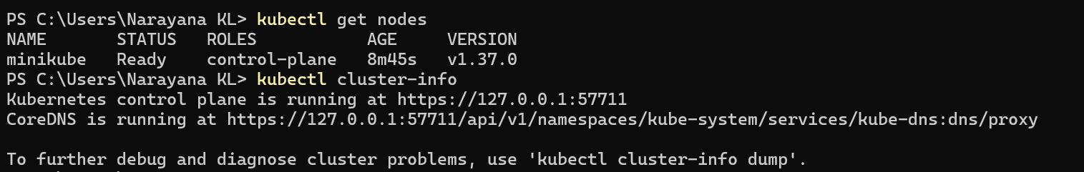
18. Step 14 — Check Kubernetes System Pods
Run: kubectl get pods -A
The -A means: --all-namespaces
You should see Kubernetes system components such as:
NAMESPACE NAME
kube-system coredns-...
kube-system etcd-minikube
kube-system kube-apiserver-minikube
kube-system kube-controller-manager-minikube
kube-system kube-proxy-...
kube-system kube-scheduler-minikube
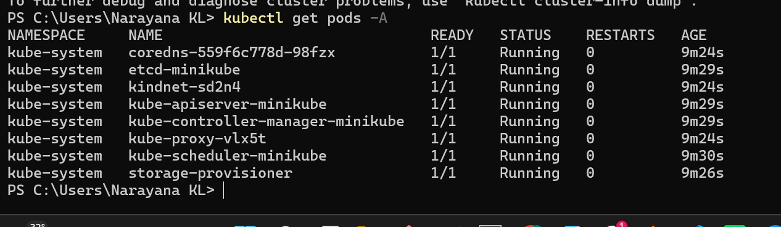
Some additional components may also appear depending on the Minikube version.
19. Step 15 — Check Minikube Nodes
Run: minikube node list
You should see the Minikube node.
For example: minikube 192.168.x.x Running
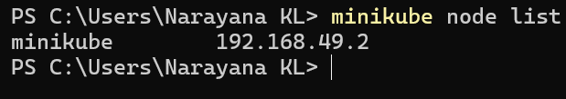
20. Step 16 — Open the Minikube Dashboard
Minikube provides a Kubernetes dashboard.
Run: minikube dashboard
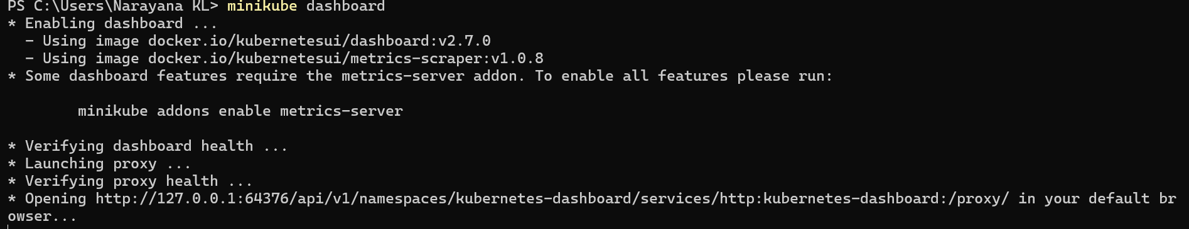
This should open the Kubernetes Dashboard in your browser.
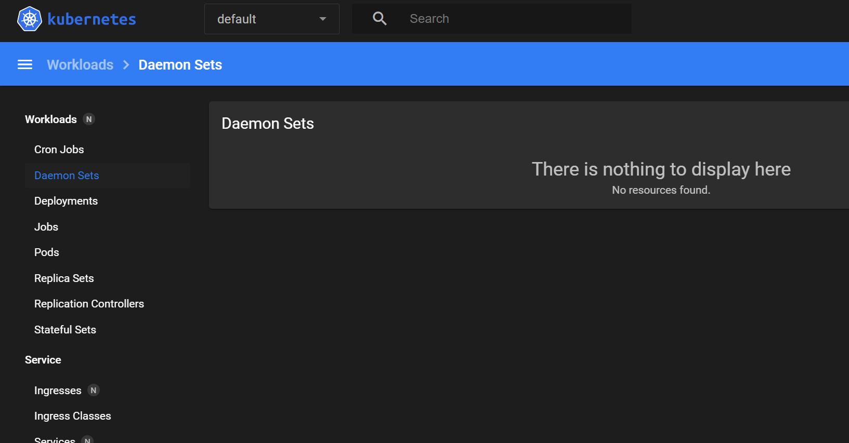
You can use it to visually inspect:
- Pods
- Deployments
- Services
- Namespaces
- Nodes
- Workloads
21. Step 17 — Final Validation
Run all these commands: docker --version
kubectl version --client
minikube version
minikube status
kubectl get nodes
kubectl get pods -A
Expected overall state:
Docker
|
+---- Working
|
v
Minikube
|
+---- Running
|
v
Kubernetes
|
+---- Node: Ready
|
+---- System Pods: Running
22. Expected Output
The most important validation is:
kubectl get nodes
Expected:
NAME STATUS ROLES AGE VERSION
minikube Ready control-plane ... ...
And:minikube status
Expected:
host: Running
kubelet: Running
apiserver: Running
kubeconfig: Configured
23. Outcome
After completing Task 1, you will have:
- Docker Desktop installed and working.
- kubectl installed.
- Minikube installed.
- A local Kubernetes cluster running on Windows.
- Kubernetes API Server accessible through kubectl.
- A Ready Minikube node.
- Kubernetes system Pods running.
Task 2 — Setup Kubernetes Control Plane + 2 Worker Nodes on Ubuntu
Objective
Create a Kubernetes cluster with:
- 1 Control Plane
- 2 Worker Nodes
- Ubuntu machines
- kubeadm for cluster creation
- containerd as container runtime
Final Architecture
Kubernetes Cluster
|
Control Plane
Ubuntu Server
|
+----------+----------+
| |
Worker 1 Worker 2
Ubuntu Server Ubuntu Server
Step 1 — Create 3 Ubuntu Machines
You can use AWS EC2 Ubuntu instances for this lab.
Create 3 Ubuntu 24.04 LTS instances.
Machine | Hostname | Purpose
Ubuntu-CP | k8s-master | Control Plane
Ubuntu-W1 | k8s-worker1 | Worker 1
Machine | Hostname | Purpose
Ubuntu-W2 | k8s-worker2 | Worker 2
For a lab, t3.small is a reasonable starting point if available.
Security Group
Allow at least: SSH TCP 22
For Kubernetes communication, the three machines must be able to communicate with each other over their private IPs.
For a simple lab, you can allow the Kubernetes nodes to communicate with each other using the VPC/private network.
Do not expose the Kubernetes API port 6443 to 0.0.0.0/0. Allow it only from the Kubernetes nodes/your required network.
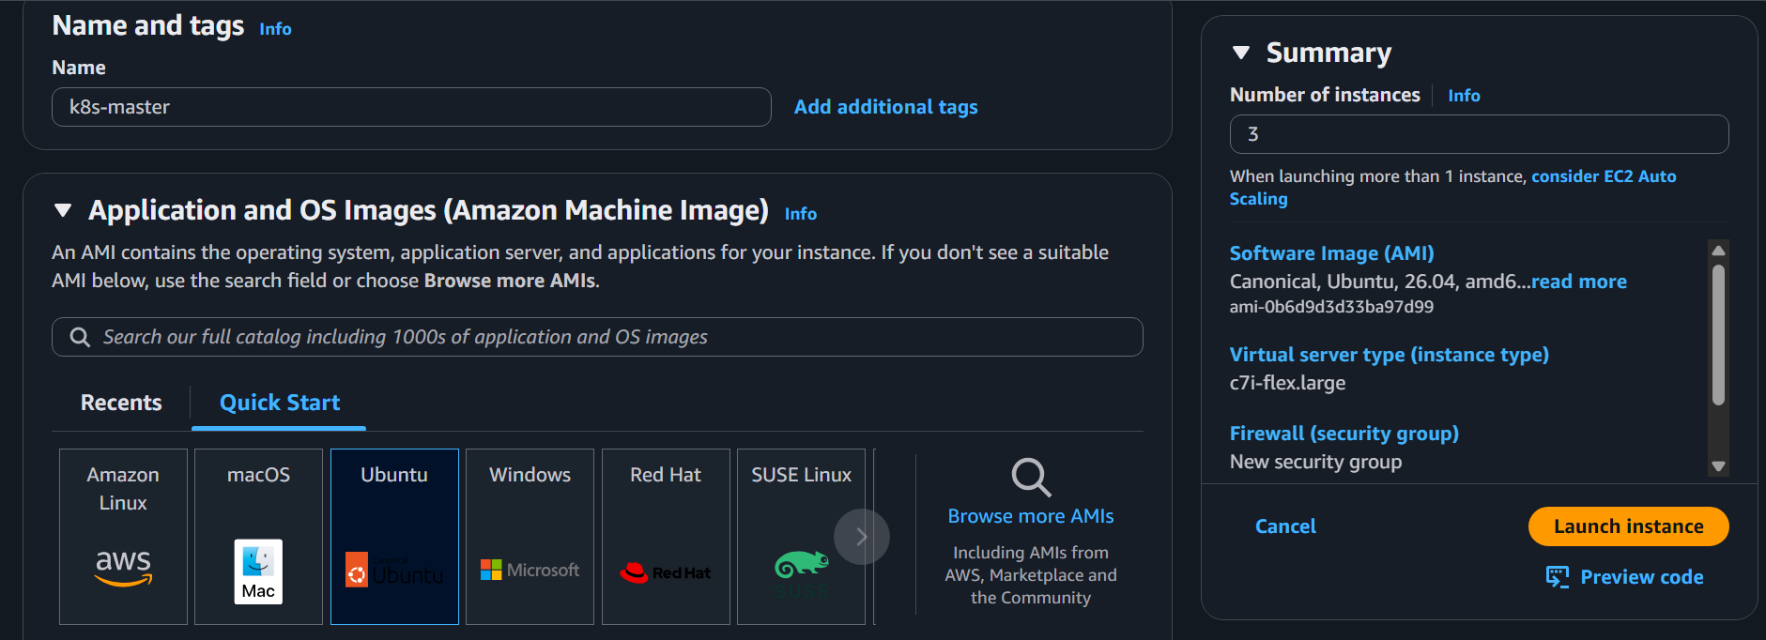
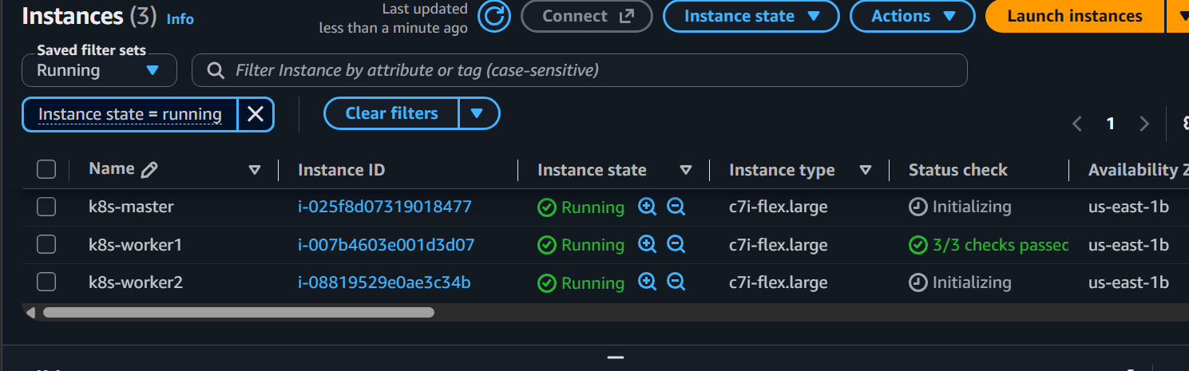
Step 2 — Connect to Control Plane
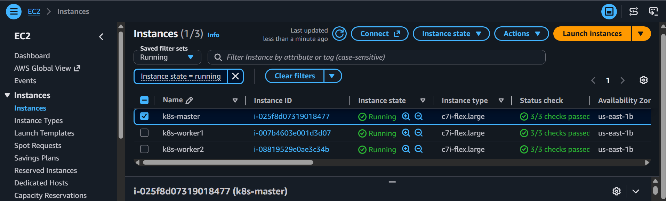
SSH into the first Ubuntu machine:
ssh -i <key.pem> ubuntu@<CONTROL_PLANE_PUBLIC_IP>
Check: hostname
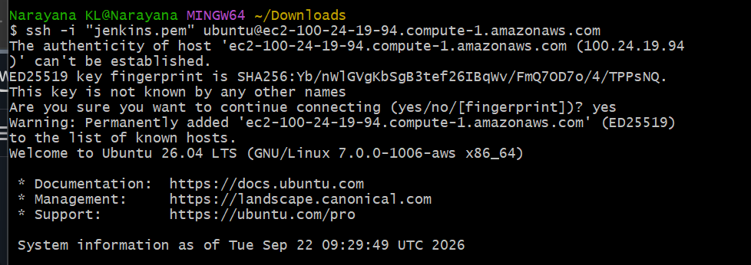
Set hostname: sudo hostnamectl set-hostname k8s-master
Reconnect or run: exec bash
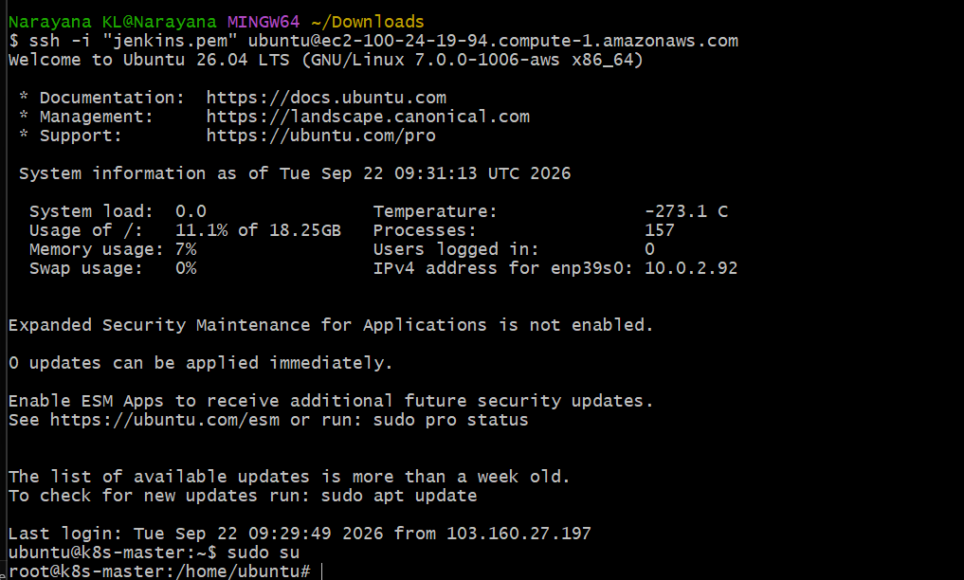
Step 3 — Configure Worker 1
SSH into Worker 1:
ssh -i <key.pem> ubuntu@<WORKER1_PUBLIC_IP>
Run: sudo hostnamectl set-hostname k8s-worker1
Reconnect: exec bash
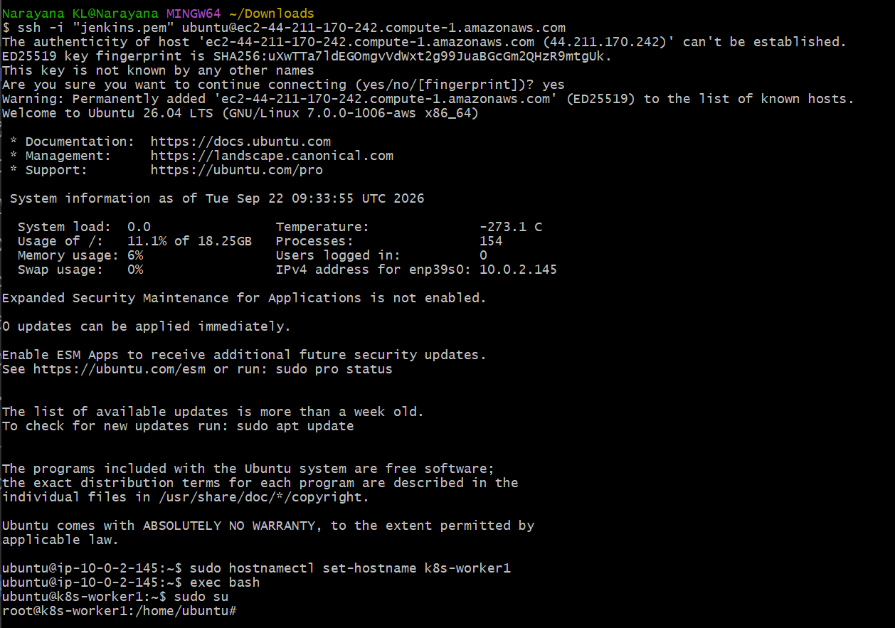
Step 4 — Configure Worker 2
SSH into Worker 2: ssh -i <key.pem> ubuntu@<WORKER2_PUBLIC_IP>
Run: sudo hostnamectl set-hostname k8s-worker2
Reconnect:exec bash
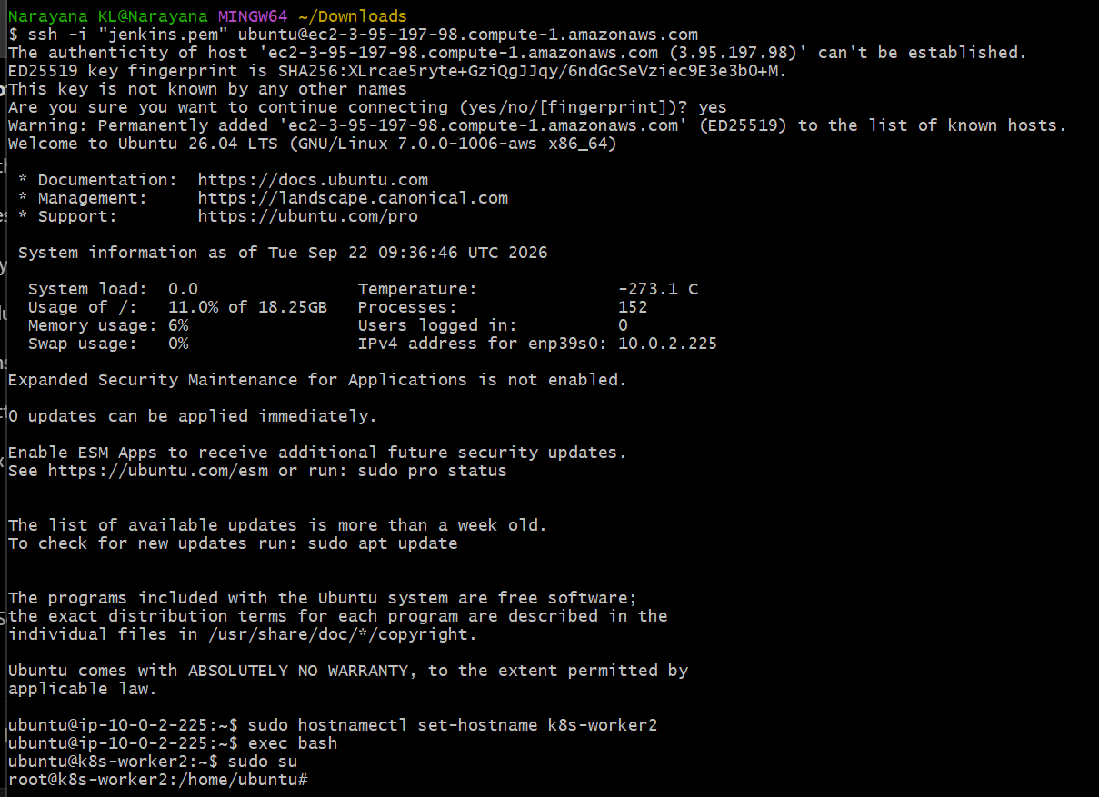
Step 5 — Update All 3 Machines
Run this on Control Plane, Worker 1 and Worker 2:
sudo apt update
sudo apt upgrade -y
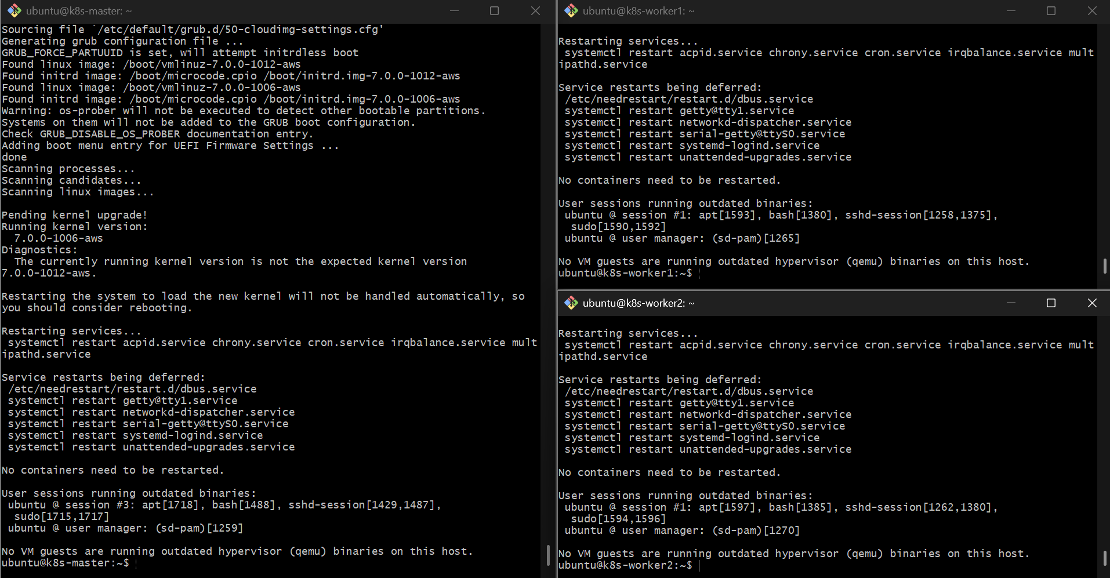
Step 6 — Disable Swap
Run on all 3 machines:
sudo swapoff -a
Disable it permanently:
sudo sed -i '/ swap / s/^/#/' /etc/fstab
Verify: free -h
Swap should be 0.
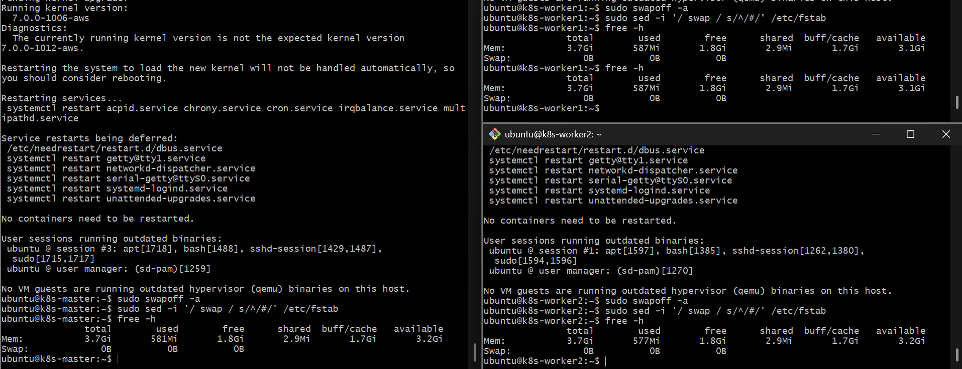
Step 7 — Install containerd
Run on all 3 machines:
sudo apt install -y containerd
Create configuration: sudo mkdir -p /etc/containerd
containerd config default | sudo tee /etc/containerd/config.toml
Enable systemd cgroups: sudo sed -i 's/SystemdCgroup = false/SystemdCgroup = true/' /etc/containerd/config.toml
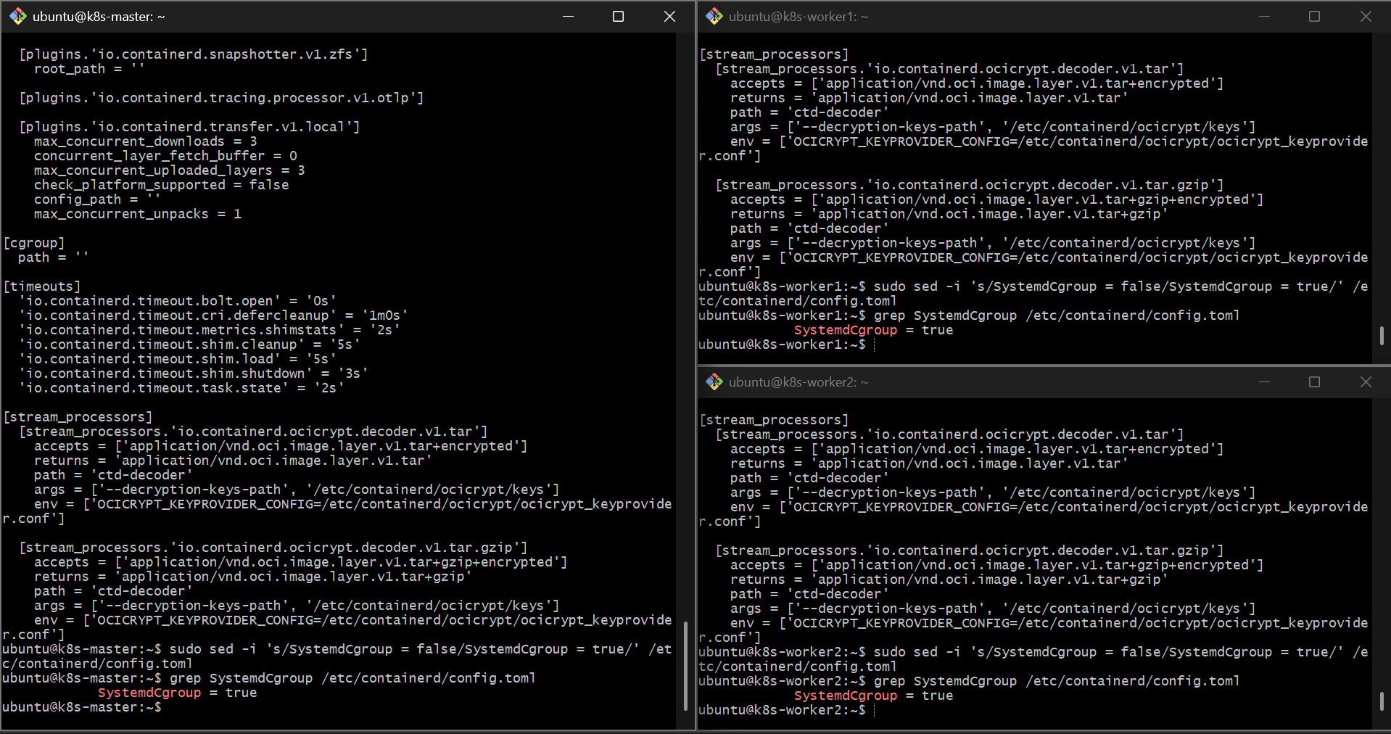
Restart: sudo systemctl restart containerd
Enable at boot:
sudo systemctl enable containerd
Verify:
sudo systemctl status containerd
You should see: active (running)
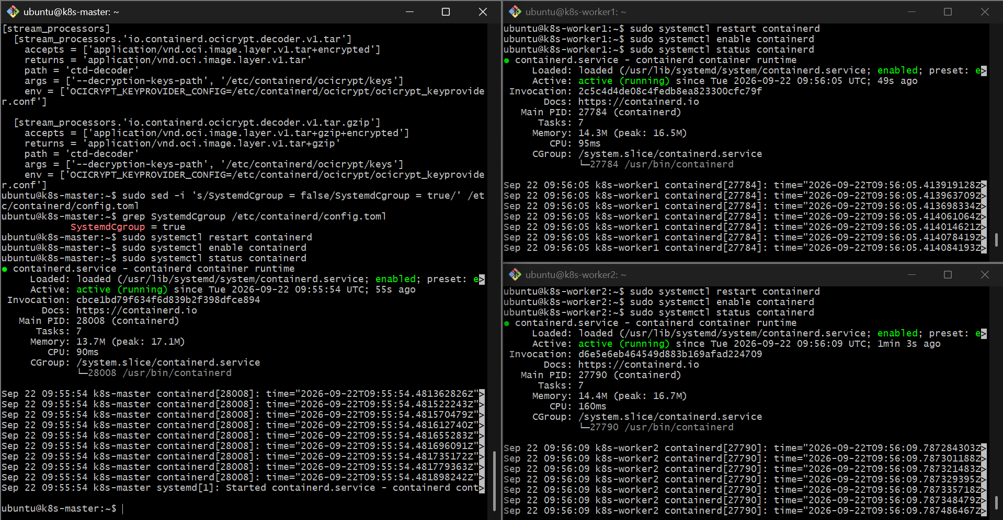
Step 8 — Install Kubernetes Packages
Do this on all 3 machines.
Install required packages: sudo apt install -y apt-transport-https ca-certificates curl gpg
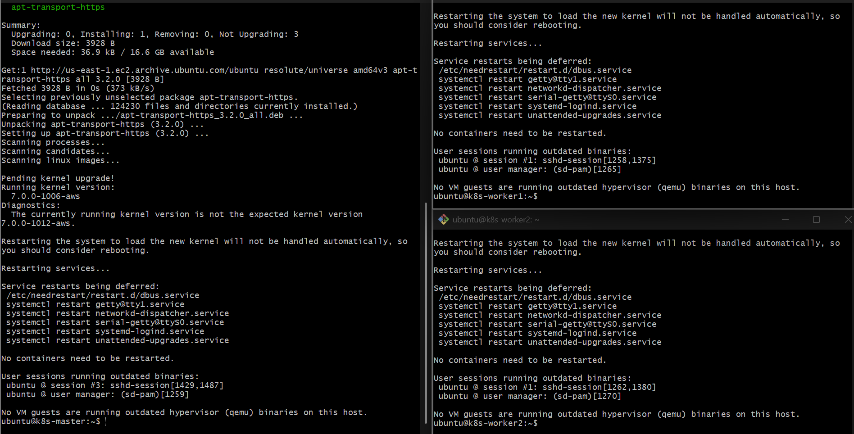
Create the keyring directory:
sudo mkdir -p -m 755 /etc/apt/keyrings
8.2 Add Kubernetes repository
For this lab, we'll use the Kubernetes v1.34 package repository so that all three nodes use the same Kubernetes minor version.
Run on all 3 machines: curl -fsSL https://pkgs.k8s.io/core:/stable:/v1.34/deb/Release.key | \
sudo gpg --dearmor -o /etc/apt/keyrings/kubernetes-apt-keyring.gpg
Then: echo 'deb [signed-by=/etc/apt/keyrings/kubernetes-apt-keyring.gpg] https://pkgs.k8s.io/core:/stable:/v1.34/deb/ /' | \
sudo tee /etc/apt/sources.list.d/kubernetes.list
Update: sudo apt update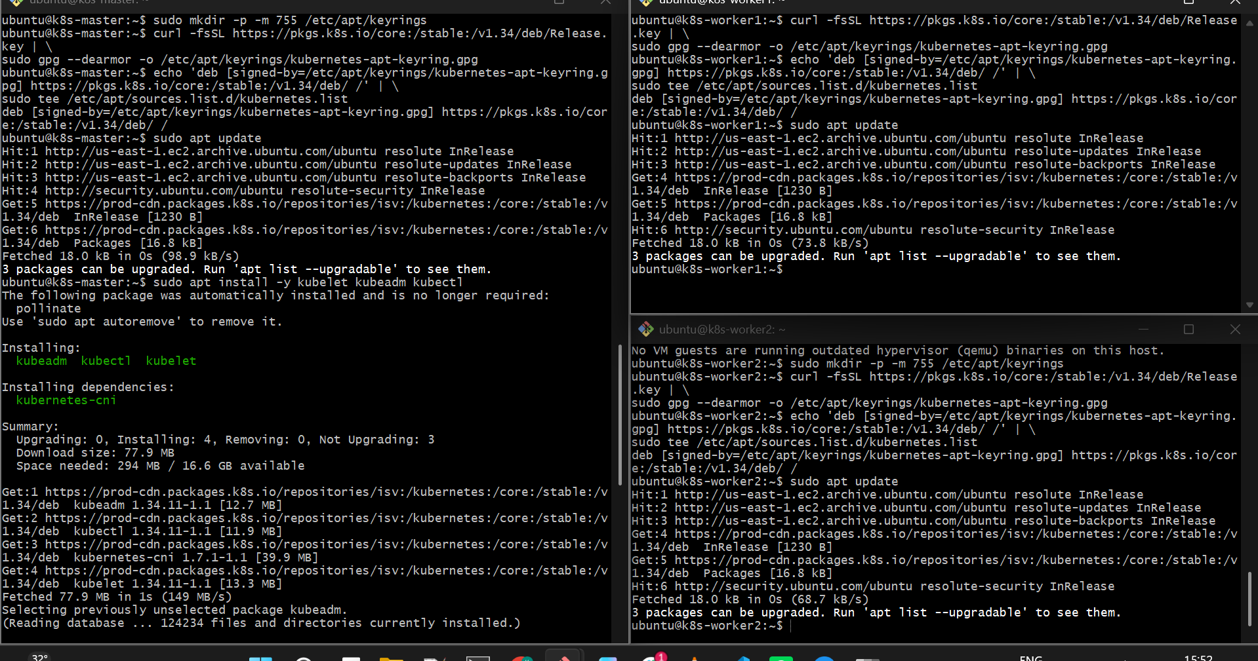

8.3 Install Kubernetes packages
Run on all 3 machines:
sudo apt install -y kubelet kubeadm kubectl
Then prevent accidental automatic upgrades: sudo apt-mark hold kubelet kubeadm kubectl
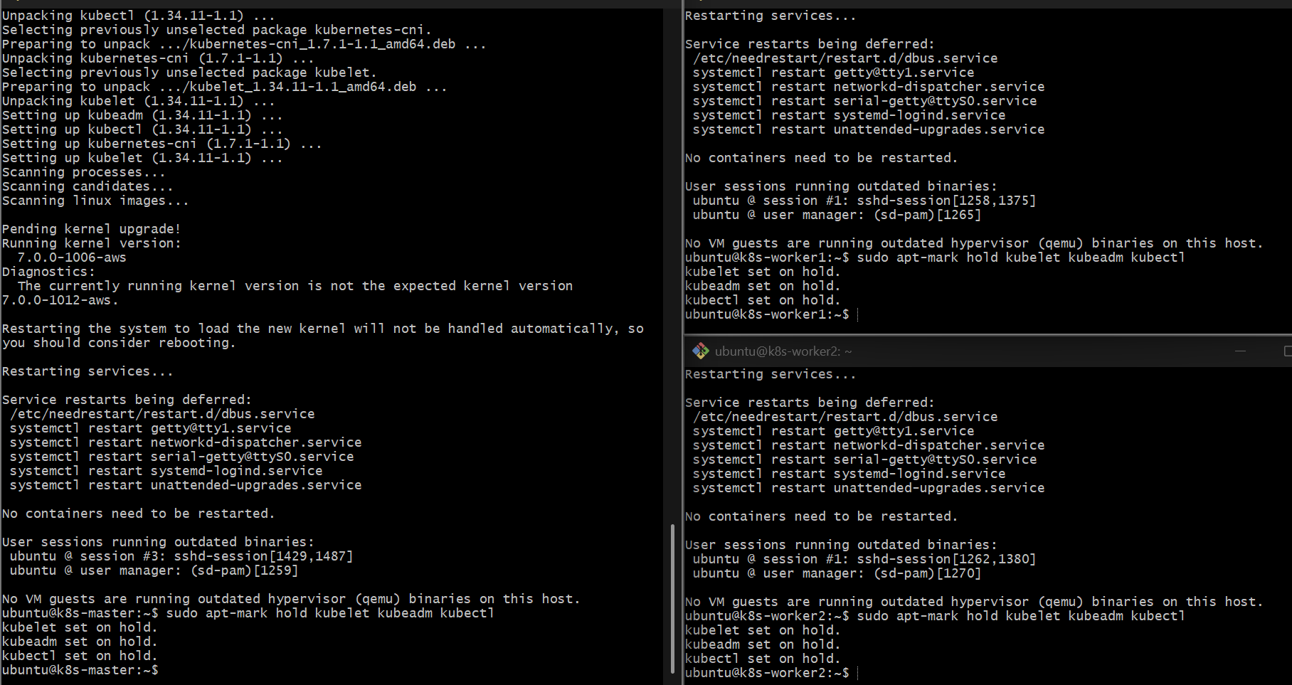
Add the current Kubernetes package repository and install:
kubelet
kubeadm
kubectl
Use the current official Kubernetes installation instructions for the repository because the repository/version path changes over time.
After installation, verify:
kubeadm version
kubectl version --client
kubelet –version
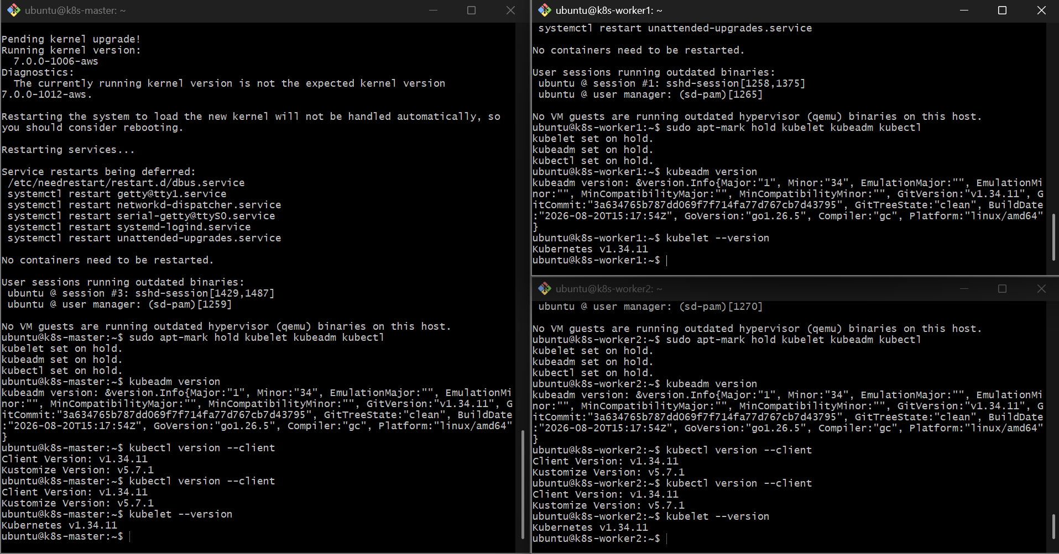
Step 9 — Initialize the Control Plane
Do this ONLY on k8s-master.
Find its private IP: ip addr
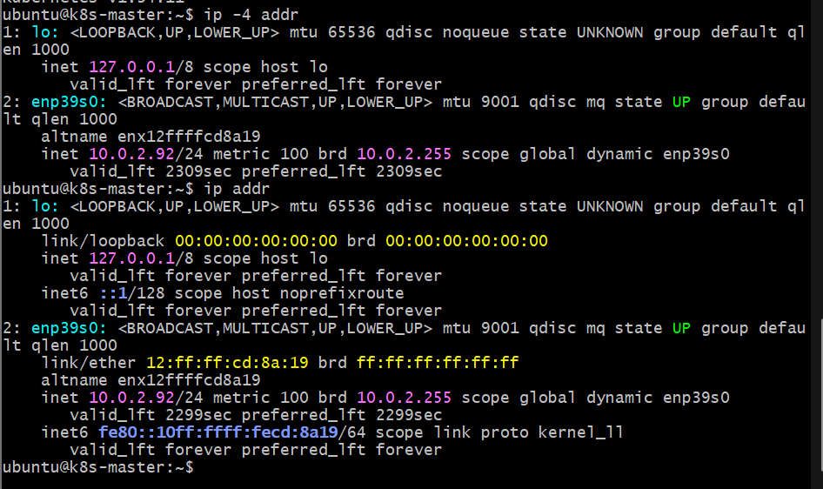
Then initialize Kubernetes: sudo kubeadm init --apiserver-advertise-address=<CONTROL_PLANE_PRIVATE_IP> --pod-network-cidr=192.168.0.0/16
Example: sudo kubeadm init \
--apiserver-advertise-address=10.0.2.92 \
--pod-network-cidr=192.168.0.0/16
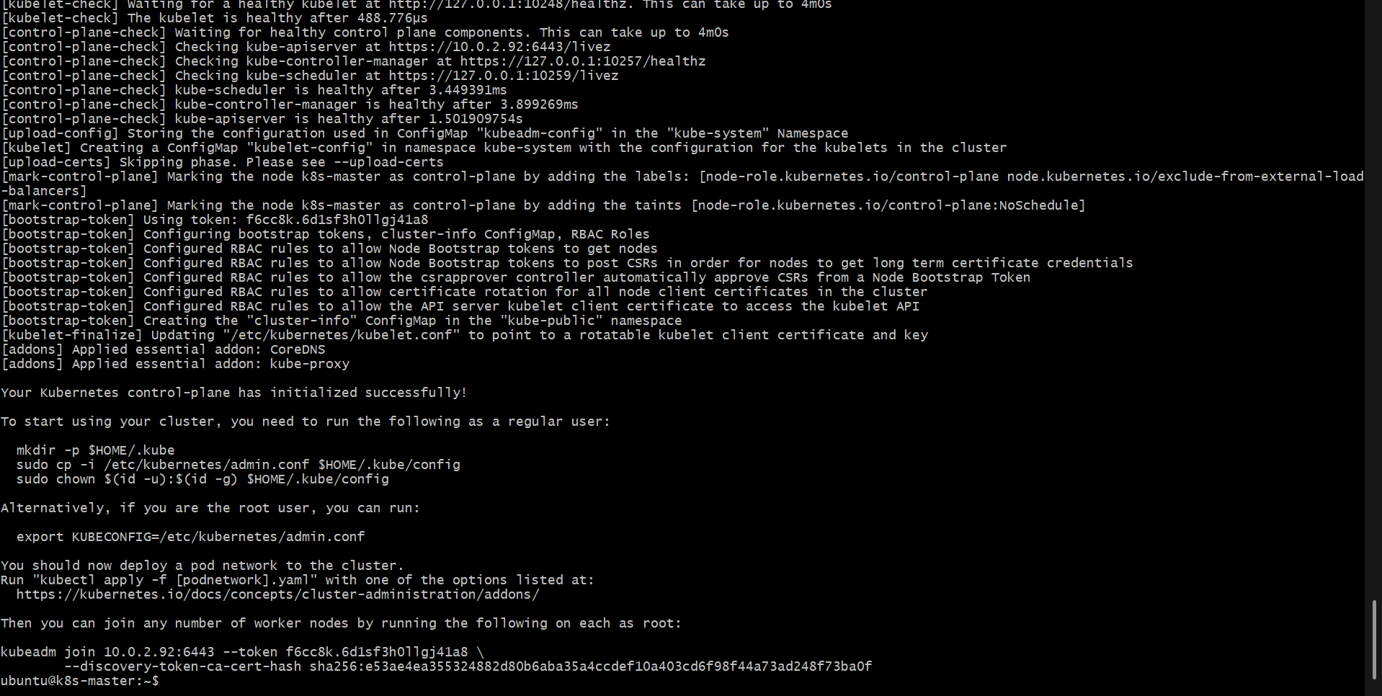
At the end, you will receive a kubeadm join command.
If it fails run the below commands and retry the above command again to initialize
Enable Kubernetes networking prerequisites on k8s-master
Run: sudo modprobe overlay
sudo modprobe br_netfilter
Then: cat <<EOF | sudo tee /etc/sysctl.d/k8s.conf
net.bridge.bridge-nf-call-iptables = 1
net.bridge.bridge-nf-call-ip6tables = 1
net.ipv4.ip_forward = 1
EOF
Apply the settings: sudo sysctl --system
Step 2 — Verify
Run: sysctl net.ipv4.ip_forward
You should get: net.ipv4.ip_forward = 1
Also check: lsmod | grep br_netfilter
and: lsmod | grep overlay
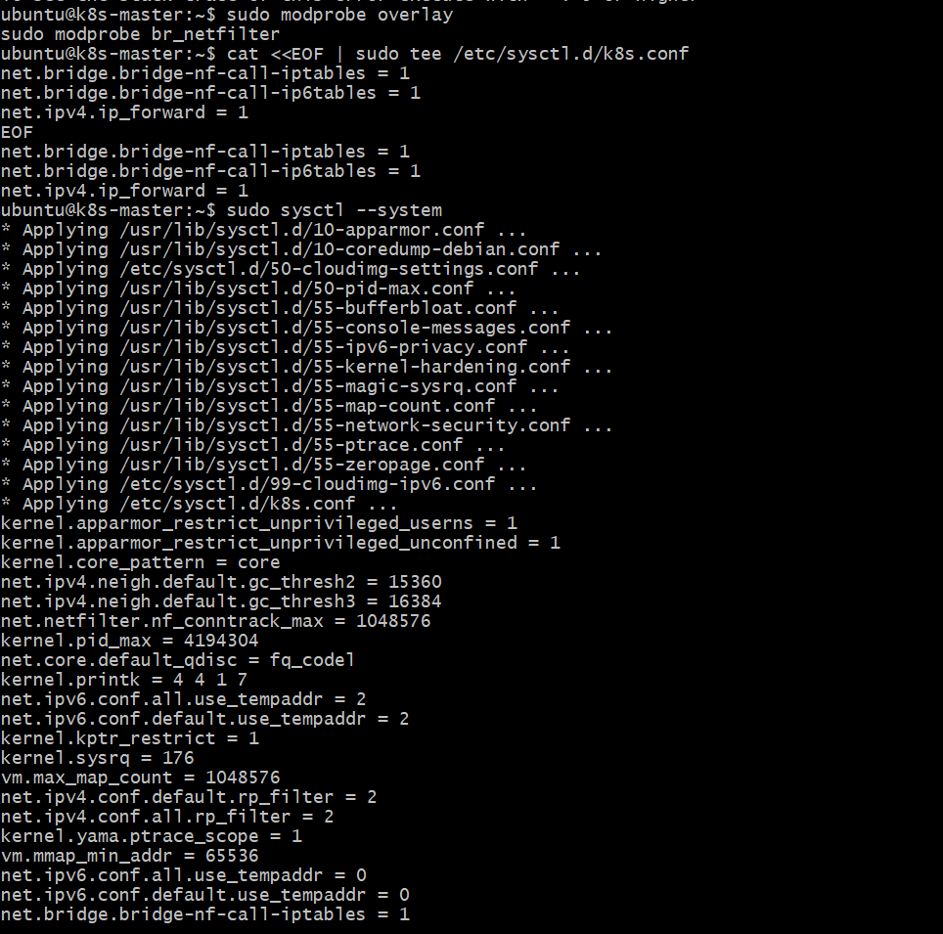
It will look similar to: sudo kubeadm join <CONTROL_PLANE_PRIVATE_IP>:6443 \
--token <TOKEN> \
--discovery-token-ca-cert-hash sha256:<HASH>
⚠️ Save this command.
You need it for both workers.
kubeadm join 10.0.2.92:6443 --token f6cc8k.6d1sf3h0llgj41a8 \
--discovery-token-ca-cert-hash sha256:e53ae4ea355324882d80b6aba35a4ccdef10a403cd6f98f44a73ad248f73ba0f
Step 10 — Configure kubectl on Control Plane
Still on k8s-master: mkdir -p $HOME/.kube
sudo cp -i /etc/kubernetes/admin.conf $HOME/.kube/config
sudo chown $(id -u):$(id -g) $HOME/.kube/config
Check: kubectl get nodes
At this point the Control Plane may show:
NotReady
That is expected because we haven't installed the Pod network yet.
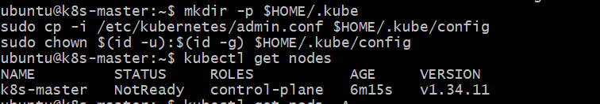
Step 11 — Install Pod Network
On the Control Plane, install a Kubernetes CNI such as Calico using its current official installation instructions.
After installation: kubectl get pods -A
Wait for the networking components to become ready.
Then:
kubectl get nodes
The Control Plane should become: k8s-master Ready
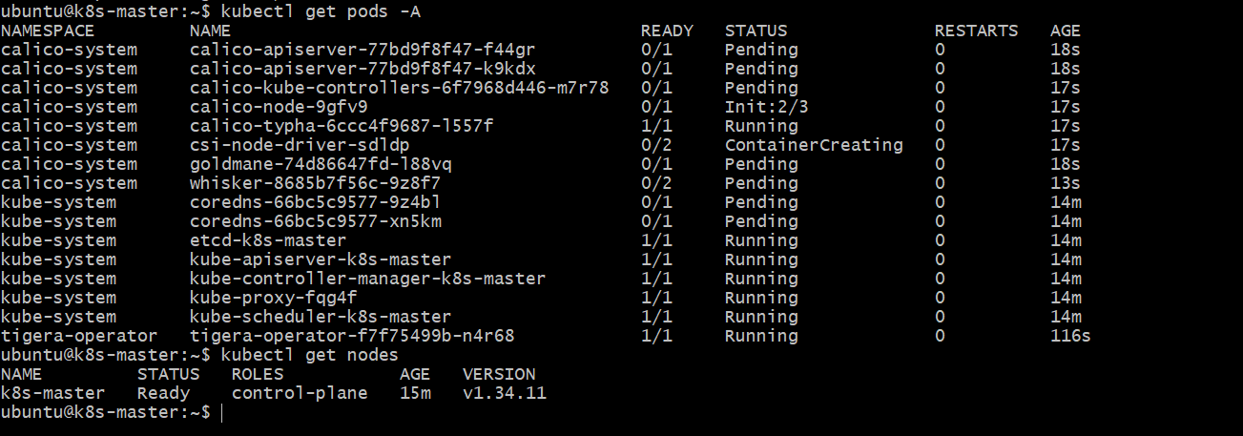
Step 12 — Join Worker 1
Go to k8s-worker1.
Run the exact kubeadm join command generated in Step 9.
Example: sudo kubeadm join 10.0.1.10:6443 \
--token <TOKEN> \
--discovery-token-ca-cert-hash sha256:<HASH>
Example : sudo kubeadm join 10.0.2.92:6443 --token f6cc8k.6d1sf3h0llgj41a8 \
--discovery-token-ca-cert-hash sha256:e53ae4ea355324882d80b6aba35a4ccdef10a403cd6f98f44a73ad248f73ba0f
If it fail to connect
Master Security Group — allow API server
Open the Security Group attached to k8s-master.
Add an inbound rule:
Type | Protocol | Port | Source
Custom TCP | TCP | 6443 | Worker nodes' Security Group

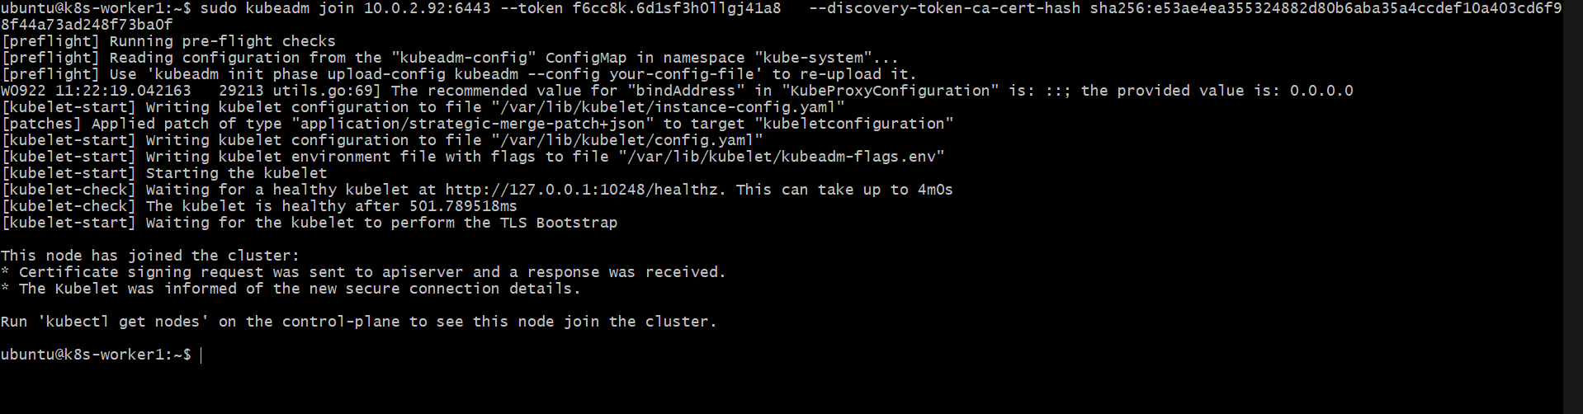
Step 13 — Join Worker 2
Go to k8s-worker2.
Run the same kubeadm join command:
sudo kubeadm join 10.0.1.10:6443 \
--token <TOKEN> \
--discovery-token-ca-cert-hash sha256:<HASH>
Example: sudo kubeadm join 10.0.2.92:6443 \
--token f6cc8k.6d1sf3h0llgj41a8 \
--discovery-token-ca-cert-hash sha256:e53ae4ea355324882d80b6aba35a4ccdef10a403cd6f98f44a73ad248f73ba0f
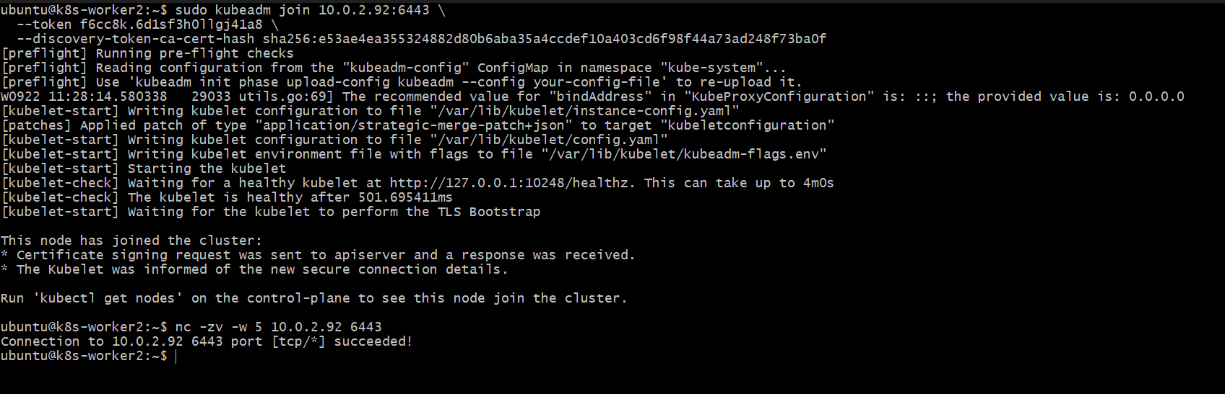
Step 14 — Final Validation
Go back to Control Plane.
Run: kubectl get nodes
Expected: NAME STATUS ROLES AGE
k8s-master Ready control-plane ...
k8s-worker1 Ready <none> ...
k8s-worker2 Ready <none> ...
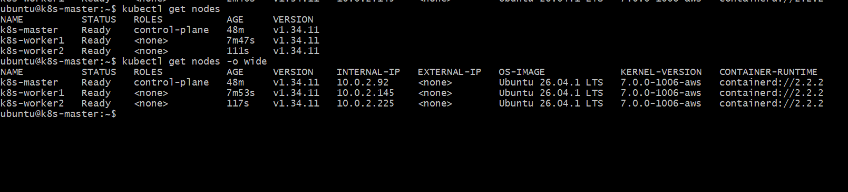
Then: kubectl get pods -A
All required Kubernetes system Pods should eventually show Running or an appropriate completed/ready state.
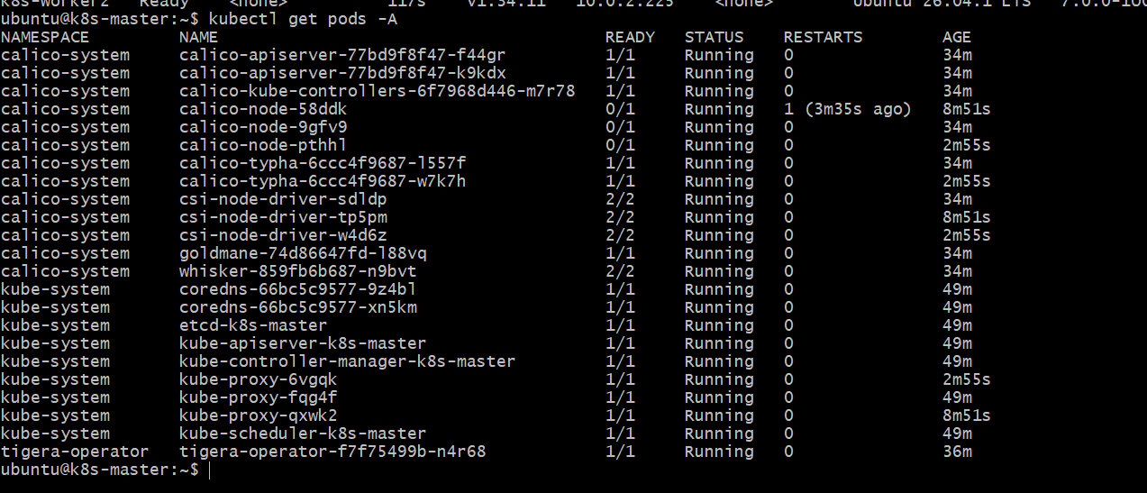
Task 2 Outcome
You have now created:
Kubernetes Cluster
|
k8s-master
Control Plane
|
+------------+------------+
| |
k8s-worker1 k8s-worker2
Worker Worker
Task 2 is complete when:
[ ] 3 Ubuntu machines created
[ ] Hostnames configured
[ ] Swap disabled
[ ] containerd installed
[ ] kubeadm installed
[ ] kubelet installed
[ ] kubectl installed
[ ] Control Plane initialized
[ ] CNI installed
[ ] Worker 1 joined
[ ] Worker 2 joined
[ ] All 3 nodes show Ready
Task 3 — Run One NGINX Pod
Objective
Deploy a single NGINX Pod in the Kubernetes cluster and verify that it is running.
Step 3.1 — Create NGINX Pod
Run this on the master:
kubectl run nginx --image=nginx
Step 3.2 — Check Pod
kubectl get pods
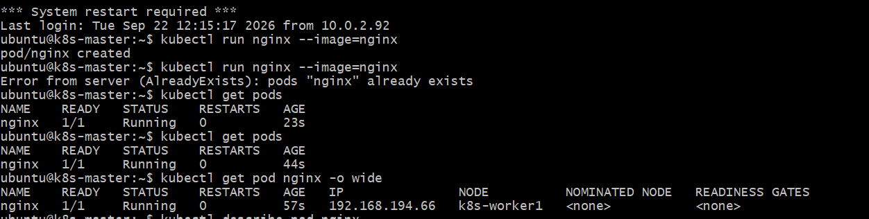
Expected: NAME READY STATUS RESTARTS AGE
nginx 1/1 Running 0 ...
Step 3.3 — Check Which Node Runs the Pod
kubectl get pod nginx -o wide
You should see the NGINX Pod assigned to one of your worker nodes.
Step 3.4 — Check Pod Details
kubectl describe pod nginx
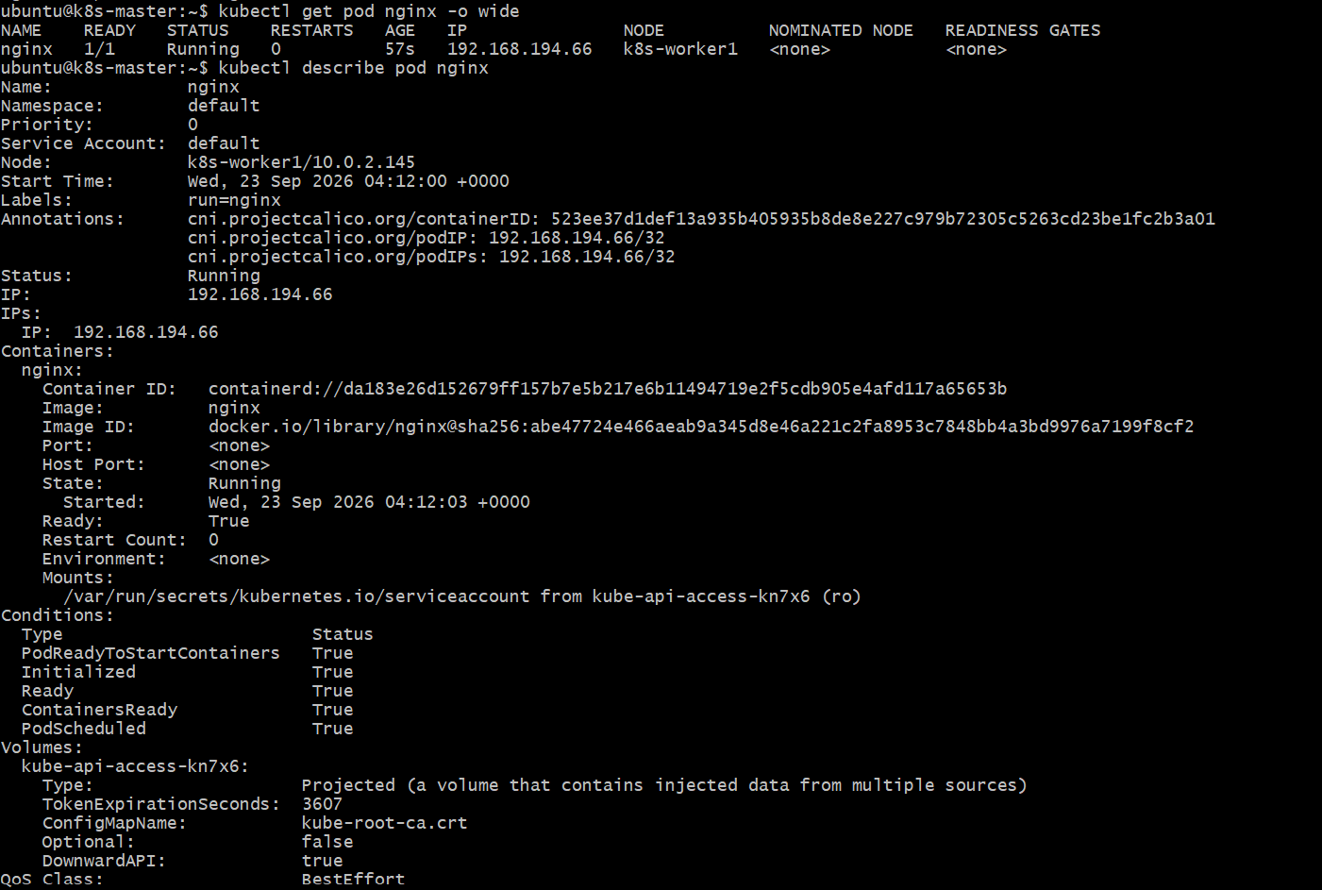
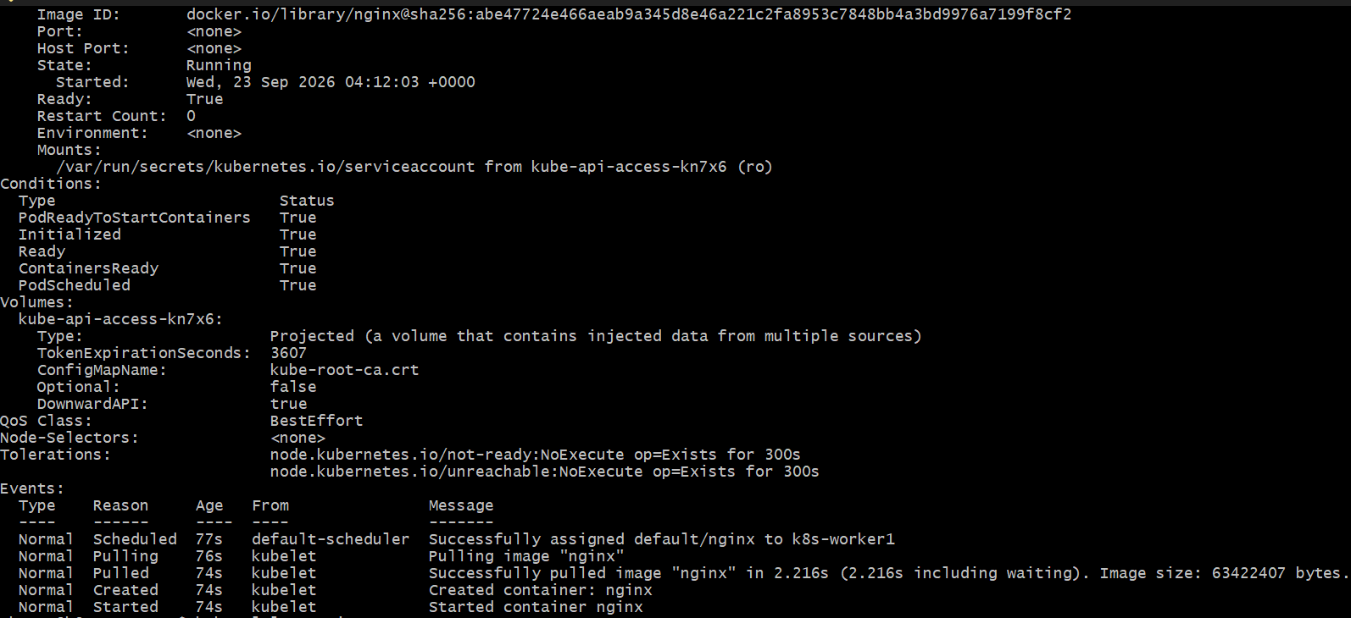
Step 3.5 — Check NGINX Logs
kubectl logs nginx
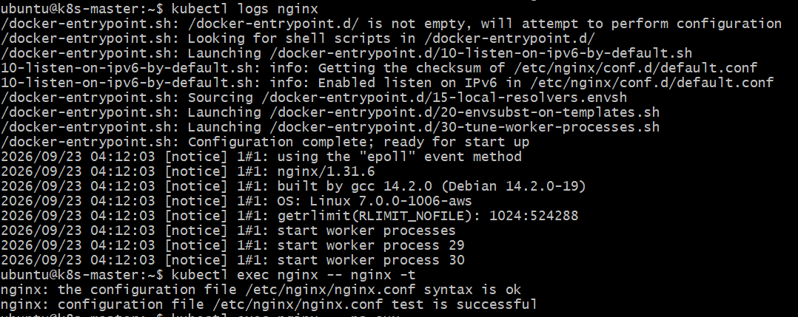
Expected Outcome
You have successfully:
Created and verified one NGINX Pod running inside the Kubernetes cluster.
Task 4 — Learn Kubernetes Components
Objective
Understand the major Control Plane and Worker Node components and their responsibilities.
4.1 Control Plane Components
Component | Purpose
kube-apiserver | Entry point for all Kubernetes API requests
etcd | Stores Kubernetes cluster state and configuration
kube-scheduler | Decides which worker node should run a new Pod
kube-controller-manager | Ensures the actual cluster state matches the desired state
4.2 Worker Node Components
Component | Purpose
kubelet | Communicates with the API server and ensures Pods are running
kube-proxy | Handles network communication and Service traffic
Container Runtime | Runs containers; in your cluster this is containerd
4.3 Simple Flow
CONTROL PLANE
┌──────────────────────────┐
│ kube-apiserver │
│ │ │
│ ┌────┴────┐ │
│ etcd scheduler │
│ │ │
│ controller-manager │
└───────────┬──────────────┘
│
┌─────────┴─────────┐
│ │
WORKER NODE 1 WORKER NODE 2
┌────────────┐ ┌────────────┐
│ kubelet │ │ kubelet │
│ kube-proxy │ │ kube-proxy │
│ containerd │ │ containerd │
│ Pods │ │ Pods │
└────────────┘ └────────────┘

